**IFB -299**

**Package Delivery**

**Personal Portfolio**

**By**

**Ahmed Shoeb Talukder**

(n9076336)

Group -114

**TUTOR**

Prakash Bhandari

28th of October 2016

Table of Contents

Release 1 3

Sprint 1 3

1. User Stories & Client Requirements: 3

2. Wireframe and Site Architecture: 4

3. Database Design 7

3. Customer Portal: 9

4. Release and Sprint plan 9

Sprint 2 10

5. Customer Portal (Continued): 10

6. Order Placement: 10

7. Delivery Details: 11

8. Unit testing: 12

Release 2 13

Sprint 3 13

1. Updated Site map: 13

2. Manager Portal Page flow: 14

3. Additional Pages: 15

4. Manager Portal: 16

5. View Financial Report: 17

6. Database Update: 17

Sprint 3 18

7. Add new employee through Manager Portal: 18

8. Business Letter: 19

9. Sprint Plans: 19

IFB-299 Group 114 was commissioned by On the Spot Packaging Courier service to develop an interactive online delivery service website. The team followed an agile methodology popularly known as scrum to develop the project. The scrum team consisted of six member with each having specific skill sets required for the project. The project was primarily divided into two major releases. Each release consisted of two sprints. Over the course of the project I have contributed in different aspects of the development acting in various roles such as a developer, scrum master, and technical report writer. My personal contributions in this project are mentioned in details in the following sections.

# Release 1

## Sprint 1

### 1. User Stories & Client Requirements:

The first stage of the scrum process is to develop user stories based on project requirements that adds business value to the clients. I developed the initial draft of client requirements from the project outline. These requirements were presented to the client and after some negotiations the draft was finalized.

User stories were developed based on the client requirements. The user stories were then prioritized based on MOSCOW analysis. I wrote the project definition and System scope. I also developed the following user stories and relevant acceptance criteria

* As a customer I want to be able to order deliveries online so that I may avoid wait times on the phone and place orders outside of business hours.
* As a Business, I want to be able to store relevant information about my customer’s online orders so that I can more easily track them.
* As a Customer, I want to be able to specify contact details of a recipient that is not me so that I may have packages shipped elsewhere.
* As a Business, I want to associate all information about an order to a single order number for easy tracking.
* As a Customer, I would like to specify a time and date for the pickup and delivery so that I can place orders ahead of time and better manage my schedule.
* As a Customer, I would like to specify the number of packages, to ensure that you collect the correct number.
* As a Customer, I would like to specify the number of packages, to ensure that you collect the correct number.
* As a delivery driver, I would like to specify the number of packages picked up from the customer, to ensure consistency with the number mentioned in the order.
* As a customer I would like to be able to specify a delivery priority so that the package will be given the needed attention
* As a Customer I want to be able to specify my contact details for future reference so deliveries are streamlined.
* As a business owner I would like to know the customer type so that I can offer promotional offers for businesses or individuals
* As a Customer, I would like to specify whether a signature is required, so that sensitive packages are cared for and goods of lesser importance can simply be dropped off at a location.

### 2. Wireframe and Site Architecture:

Wireframes were developed to visualize the site navigation and integration with the backend database. I developed the initial wireframes as a design artefact to depict the flow of pages in the website. Similar websites were researched before designing the page flow. The navigation was kept fairly simple for first time users and resembles similar websites so that customers feel familiar with the site.

The designs were presented to the client team for their valuable feedback. Some changes were made to the user interface and the navigation menu based on the client feedback.

**Mind Map**

During the initial brain storming session with the developer team and the client team various ideas related to the website were formulated. This ideas were represented in mind map for better visualization. Subsequent design aspects were based on the developed mind map in the following image. The mind map contributed in capturing all the ideas in the initial stage and in designing subsequent artefacts.

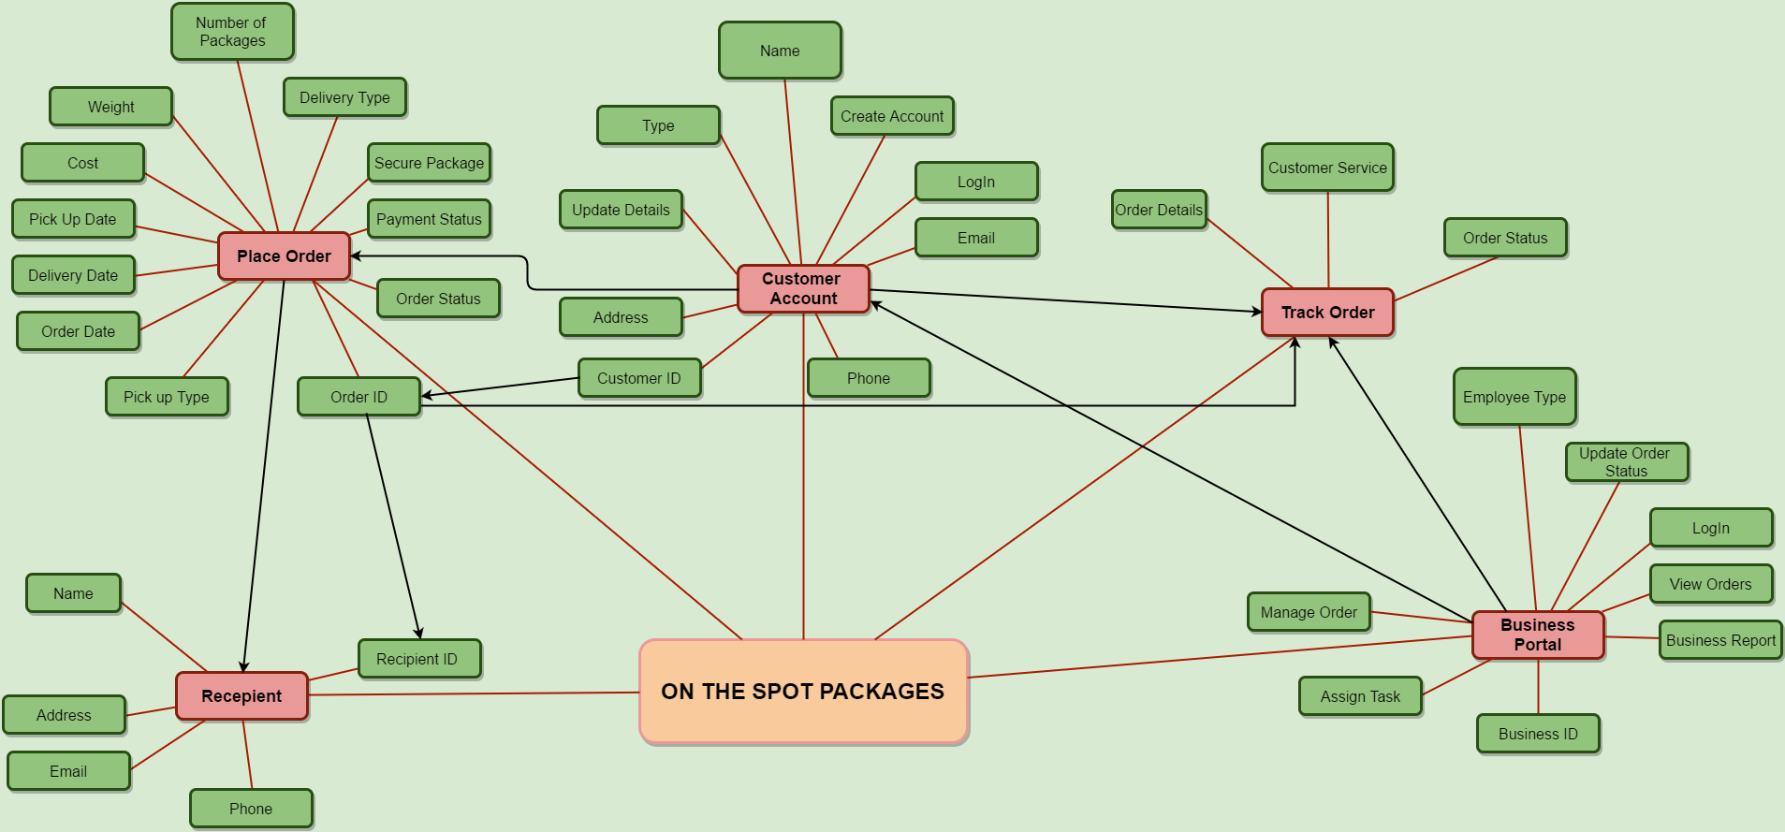

Figure 1: Release 1 Site Mind map

**Page Flow**

Customer Portal Page Flow:

The website had three major sections each separated from one another with different sets of functionalities. Each of the three major portal can be accessed from the home page. User can log in to their respective portal through the log in form in the home page.

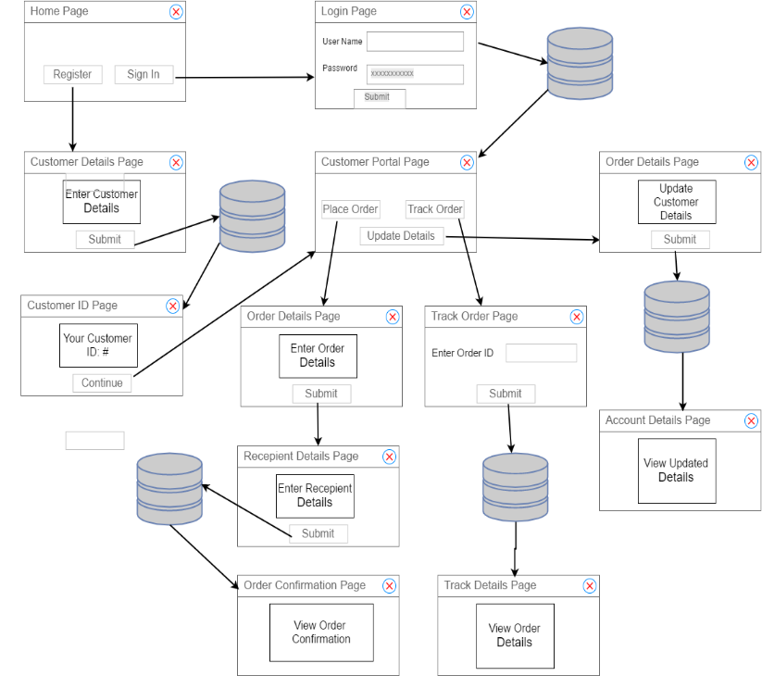

Figure 2: Customer Portal Page Flow

Once the user enters their credentials the server checks if the user input matches the corresponding data in the database and grants access to the user based on that. At first I designed the customer portal during sprint 1. The customer portal had the following functionalities

* Customer can place order by providing relevant details
* The cost for the order is generated based on the number of packages, order type and total weight
* The cost is displayed to the customer. The customer can either change the order or continue to the next step
* Customer can input delivery details through the portal
* Once the order is finalized the customer will be provided with an unique order ID for tracking the order
* Customers can track any order with the unique order ID
* Customers can update personal details through the portal
* Every customer input is validated before storing the data into the database

The link between the database and the customer facing site is also represented through wireframe in order to represent the back-end integration.

Driver Portal Page Flow:

The driver portal was designed during the second sprint. The staff members can log into the portal using their respective credentials. The server side can differentiate between different ID’s to identify if the user is a staff or a customer.

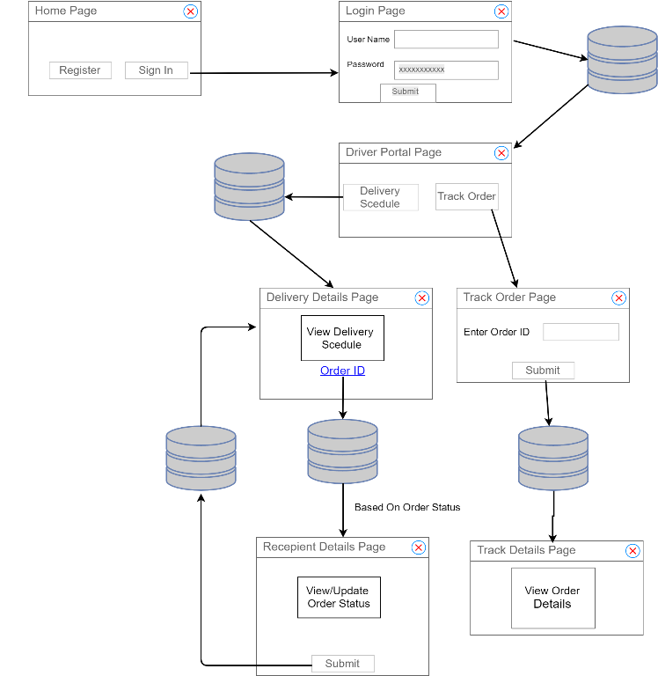

Figure 3: Driver Portal Page flow

The driver side was designed in such a way that the data was updated immediately once a change was made. The changes were also reflected in the customer portal in real time. The driver site had following functionalities

* Drivers can view assigned order schedules
* Drivers can update order status
* Drivers can search any order

**Site Architecture:**

Site architecture (figure 3) developed during sprint 1 & 2 provides an over view of the functionalities of the website. It also shows a hierarchy of pages in the website and how each portal is related to one another. I designed the site architecture as a design artefact for the client team to provide a full overview of the finished website.

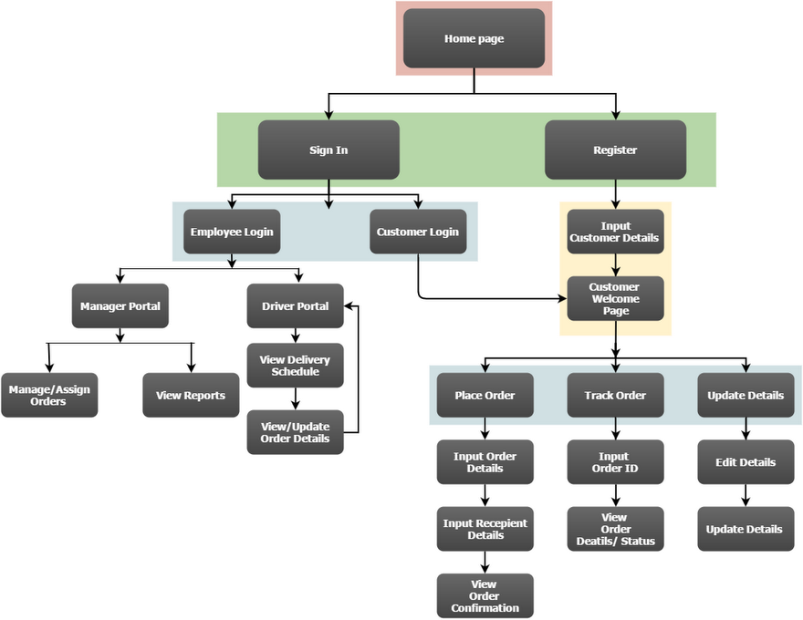

Figure 3: Site Map

The site map presented in the above figure is an incomplete representation of the final design. Additional pages were added to the map in later release.

3. Database Design**:**

Database is an essential part of any server back-end. It captures all the necessary data required by the business without any redundancy. As a part of the user story **AACXIV-33: Ordering Database,** I developed the initial entity relationship diagram for the website. Database Management System (DBMS) manages the interaction between the end user and the database. For this particular project I decided to choose Relational DBMS (MySQL) for its performance and availability. Entity Relationship Diagram (ERD) was used for graphic representation of the database models. The visual representation of the ERD makes it an effective communicating tool. Four key entities were identified in designing the database which is shown in flowing figure

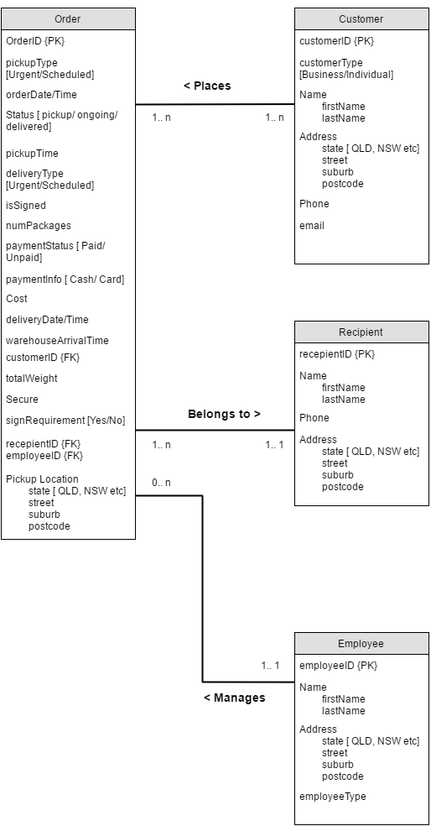

Figure 4: Site Map

The relationship between each entities provided a further insight to the data flow in the website. The multiplicity of the ERD also helped in visualizing the scalability of the website. The ERD was modified in subsequent sprints as more data fields were added to the website. Once the relationships of the ERD was identified the associated attributes of the entities were formulated. I also determined the primary keys for each entity and the foreign key constraints of the database for completing the user story **AACXIV-7: Unique Order ID**.

Once the ERD was finalized, it was converted to a relational model with tables and columns. The database model was finalized after normalization for avoiding any redundancy. I also implemented the database developing the MySQL scripts.

Mock data was entered into the database for testing purposes. The database was testing manually in most cases. The data entered into the database by the system was visualized in order to ensure consistency and uniqueness. The database was also tested through the course of the development phase by testing other functionalities that used the database.

### 3. Customer Portal:

Once site architecture was finalized in the first week of sprint 1, I developed the HTML elements for website homepage and navigation bar as a part of user story **AACXIV- 4: Design and Develop Customer website**. The resolution of the website was fixed at 1280 x 800 pixels, the website was designed based on the prototype design developed by the design team. The navigation bar of the website provided a quick of the site to the user. Users can easily look at an overview of the company before deciding to join the business.

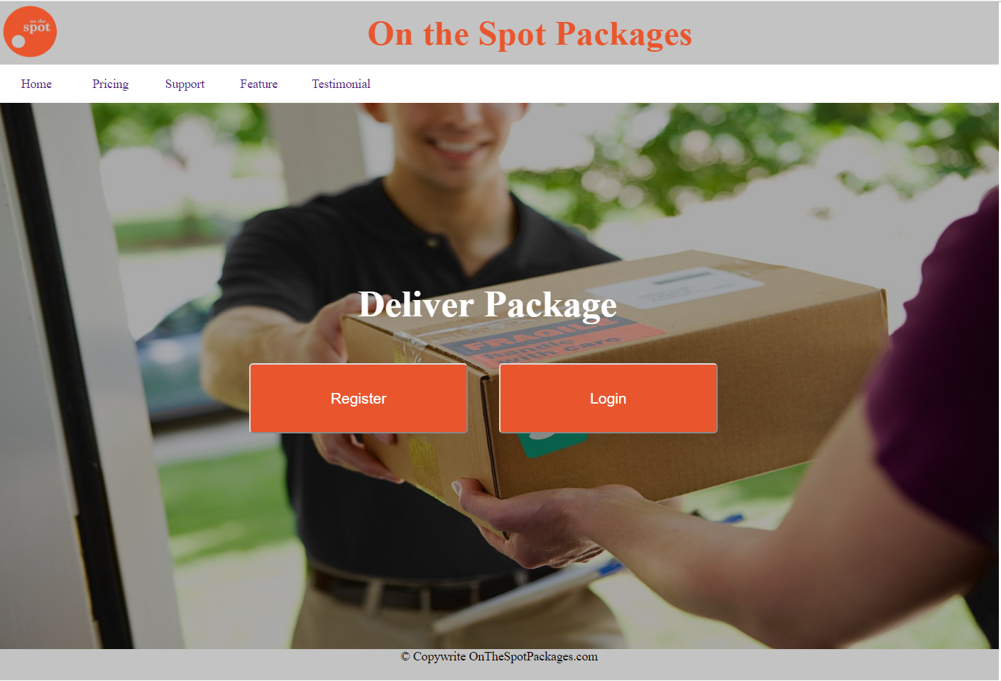

Figure 5: Screenshot of the website Homepage

The homepage design provided a standard layout which will be used across the website for keeping consistency. The backend of the home page was developed using PHP. The buttons were made responsive to user input which provided the team with an interactive website. Please refer to the attached source code for further details.

4. Release and Sprint plan**:**

I also helped in designing the release 1 & 2 plans based on the MOSCOW analysis. The first release of the development cycle aimed to deliver a fully functional website with basic functionality.

At the end of sprint 1, I helped in planning the tasks for the next sprint. Some of the tasks which were incomplete during the sprint 1 was pushed to sprint 2. I calculated the team velocity from the first sprint and designed the next sprint accordingly. The sprint 2 was designed in such a way that the completed user stories would produce a functional website for release 1.

## Sprint 2

### 5. Customer Portal (Continued):

In sprint 2 I focused on completing the user story (AACXIV- 4) from the last sprint. Customers can input their details through the website for creating an account. A unique customer ID is generated randomly each customer. Each customer details were validated on the server side for any errors. Customers were also prompted to fill in any mandatory details.

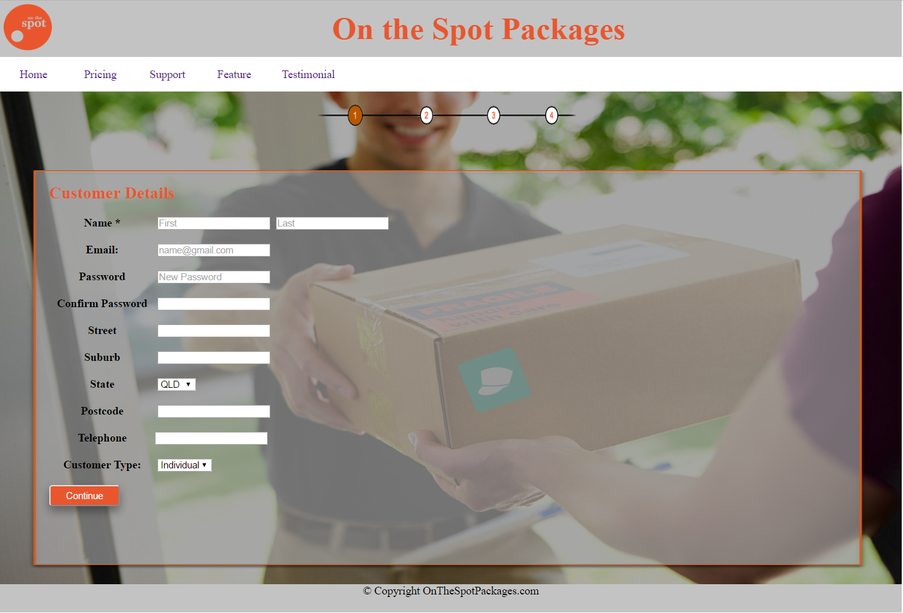

Figure 6: Screenshot of the customer details input page

Automated unit testing was implemented for testing the functionality of the page. Mock customer details were entered to check whether the input validation functions are working as expected. Mock customers were also used to populate the database to check if unique customer IDs are created for each customer. Completion of the user story contributed to a major functionality of the website. Customers can now create their own account through the website which is essential for a functional customer portal. This also provides value to the customer experience and usability.

### 6. Order Placement:

In the later of sprint 2 I worked on developing the HTML form to enter order details for the delivery. Once the customer submitted the order details, the server side would generate the cost based on the details and display it to the customer **(AACXIV-6: Cost Estimation)**. The customer can then choose to modify the details or continue to the next step. A unique order ID is generated for each order. Since a customer requires account in order to place the order, the order details are linked to the specific customer in the back-end. Customer can then search the order through the portal. According to the user story requirements each customer can input the preferred pickup/delivery time, number of packages, pick – up location as per requirements of the user stories of **AACXIV-9, AACXIV-10, and AACXIV-12**.

The above developed functionalities contributed in major functionalities of the website. Customers can now place an order through the portal. Automated unit testing was implemented for validating each of the user stories.

### 7. Delivery Details:

The final step of the order placement process is to enter the recipient details which was implemented at the later stages of sprint 2. The functionalities were similar to the orders form where the user enters the relevant details through a HTML form. The implementation completed the user story for **AACXIV-5: Recipient Contact Details Input**. With the implementation of the above mentioned user stories a customer can now create an account, place an order and provide delivery details. A confirmation page was also added at the end of the process which provided the customer with a unique order ID. The functionalities were tested through automated testing.

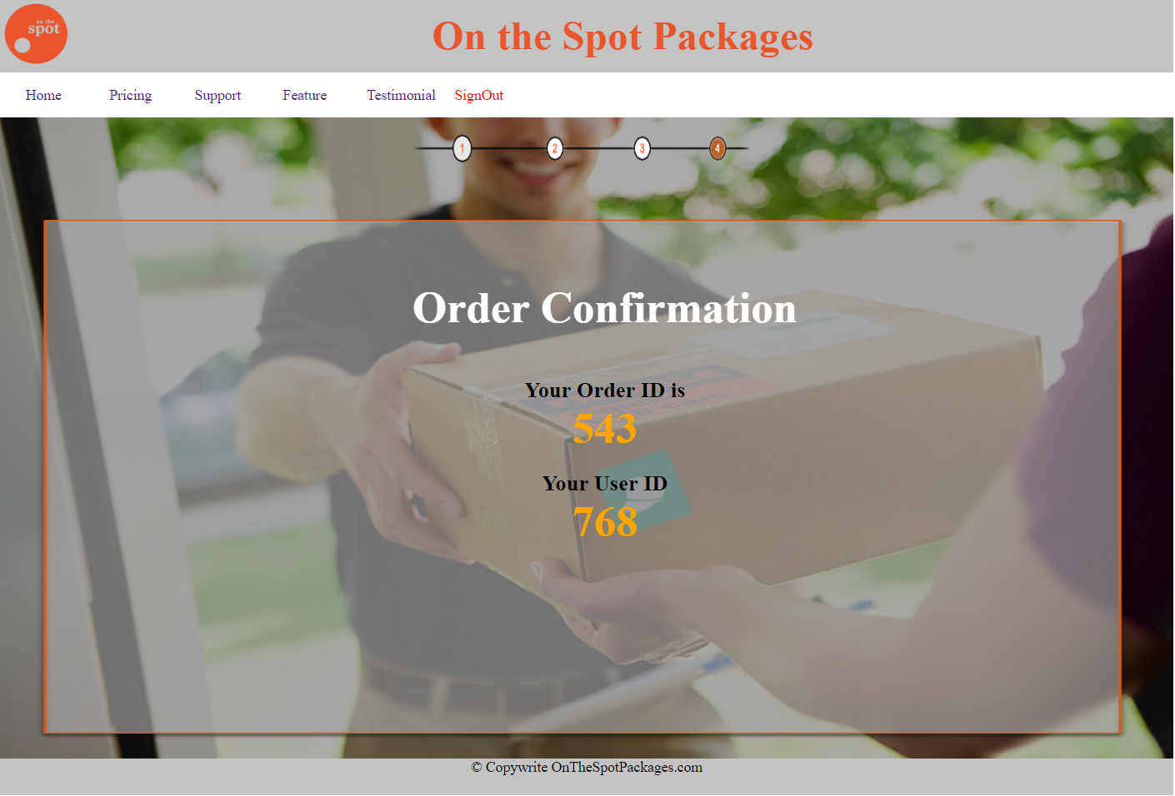

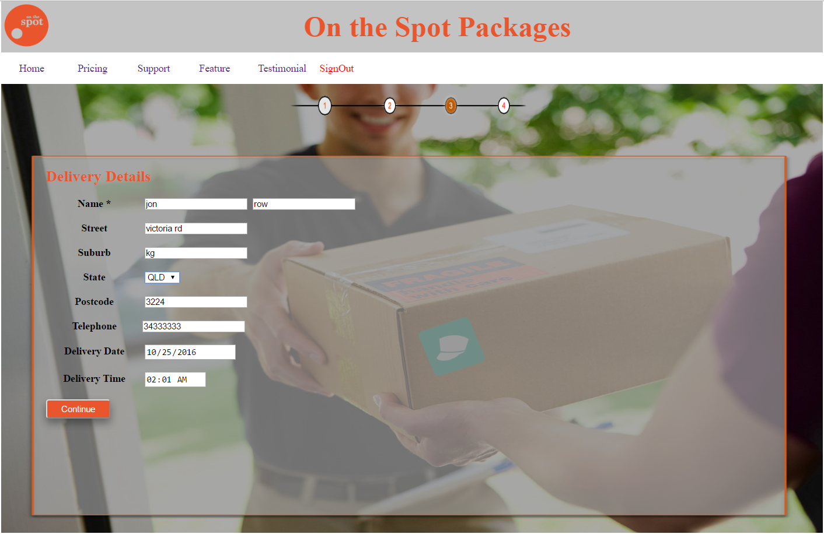

Figure 7: Screenshot of the delivery details and the order confirmation page

### 8. Unit testing:

Unit testing play an important role in validating the developed user stories. Testing ensures that the developed functionalities adheres to the acceptance criteria of each user story. Automated testing is widely used in scrum process for scalability and repetitive testing. I developed unit tests for each of the above mentioned completed user stories. Selenium IDE was used for interface testing which is an integrated development environment for Selenium scripts. It is implemented as a Firefox extension, and allows to record, edit, and debug tests. Unit tests were presented to the client team in order validate each of the user stories. It also helped the developers in identifying any bug in the program. Integration tests were also performed across the website for ensuring each of the page of the website interfaced with each other properly. Manual testing was also conducted in areas where appropriate especially checking if the website catches invalid data or negative number entered by the user, invalid postcode, phone numbers or email address.

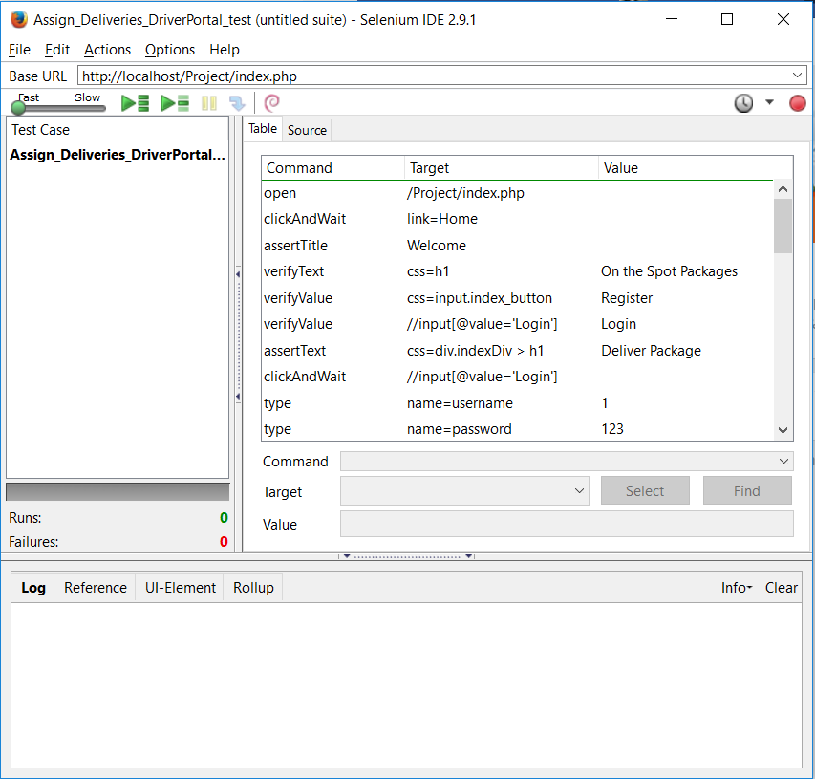

Figure 8: Selenium Unit testing

# 

# 

# Release 2

## Sprint 3

### 1. Updated Site map:

I updated the site map from release one in order to the site structure of the manager portal. The manager portal was integrated with the staff portal with a default ID of 1 for the manager. The updated site map in the following figure represented the final design of the website with all the pages and functionalities. Additional pages were also added to the website. The ‘’Pricing” page showed the costs of different types of delivery so that customers can get a better idea about the delivery cost before ordering. The “Support” page provided details about the customer services. The “Feature” page provided an overview of all the services offered by the site.

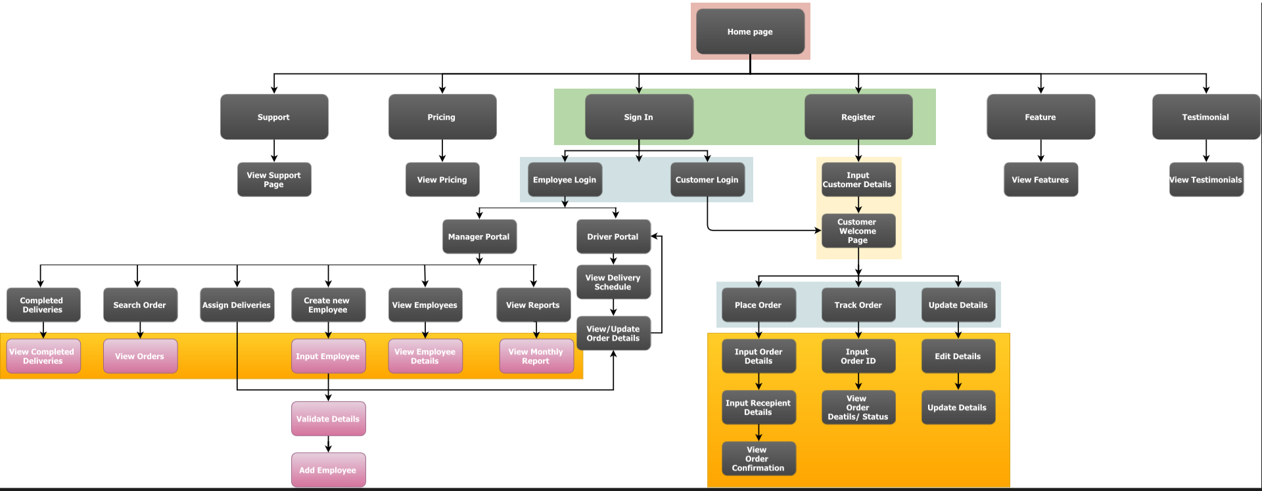

Figure 9: Updated site map

The additional pages provided a quick overview of the business and different types of facilities offered by the site. This also increased the aesthetics of the website providing quick access to essential information.

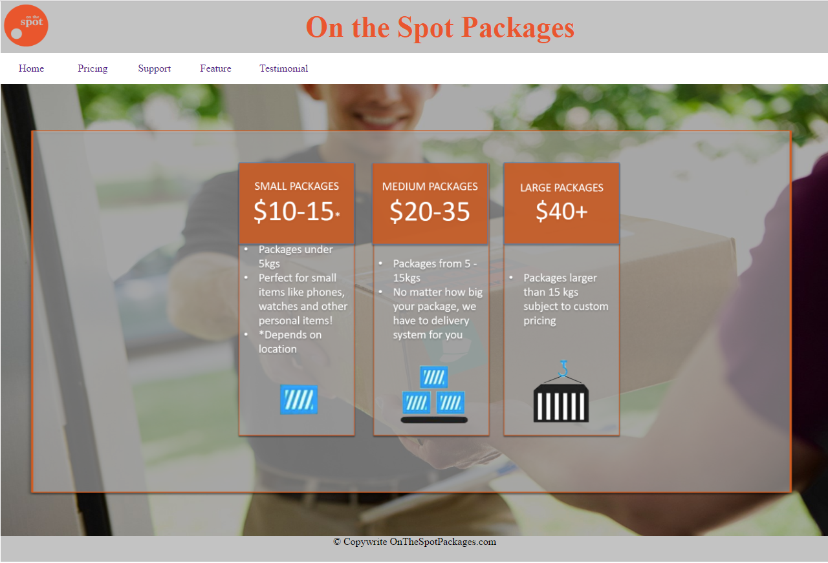

Figure 10: Pricing page of the website

### 2. Manager Portal Page flow:

Manager portal can be accessed in similar fashion as that of other portals. Manager portal was designed during sprint 3. Manager portal can display data about both the customers and the staff. Manager portal provided the following functionalities

* Assign deliveries
* Add new employee
* View employees
* View financial report
* Search order
* View completed deliveries

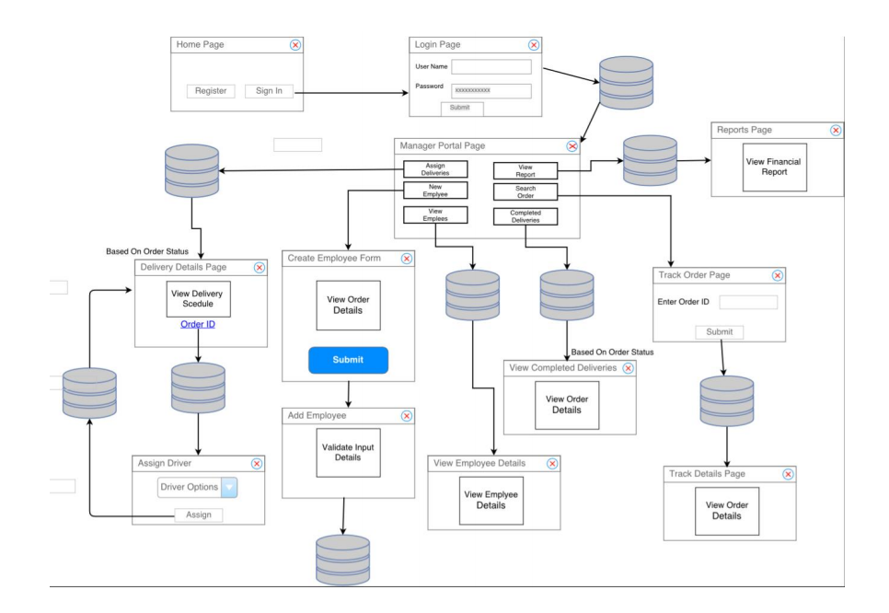

Figure 11: Manager Portal page flow

### 3. Additional Pages:

Additional pages were added to the “Home” page for quick access to essential information for the customer. The “Pricing” page (figure 12)outlined the shipping cost for different types of packages so that customers can get a better idea about the delivery cost.

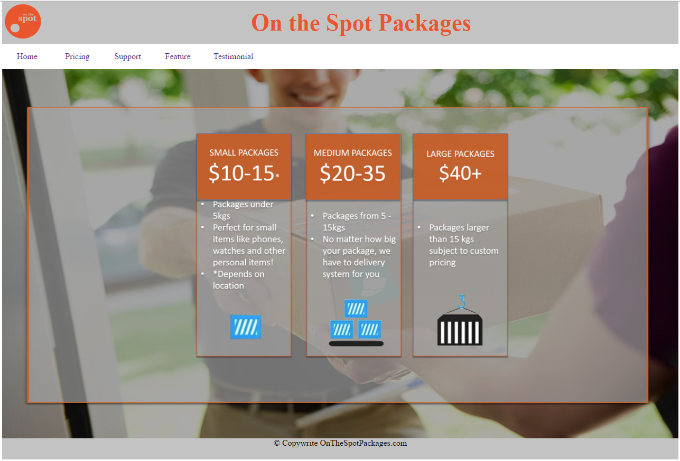

Figure 12: “Pricing” page of the website

The support page provided information about customer service which is an essential part for the business. The “Feature” page outlines the various services offered by the site, which provides a quick overview of the business to the customer.

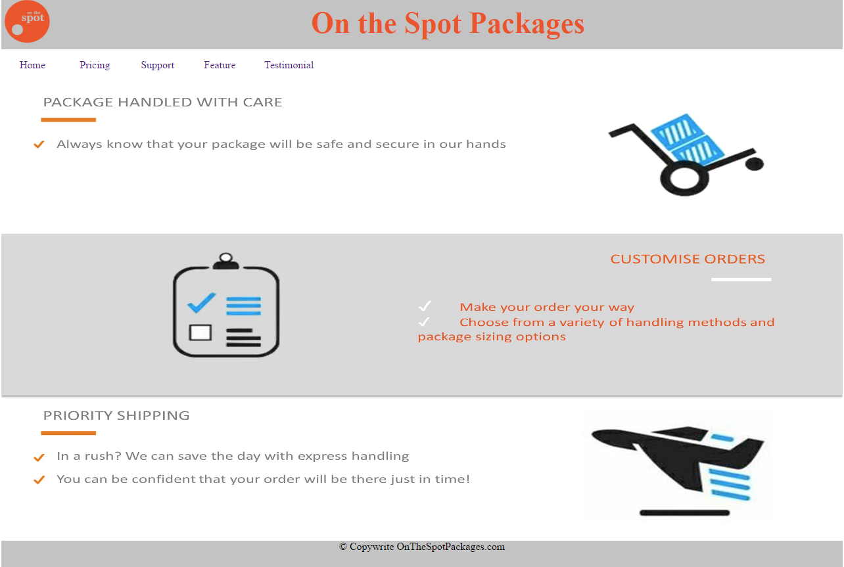

Figure 13: “Feature” page of the website

### 4. Manager Portal:

A manager can add new employees, assign orders, and view financial reports and employee details. The design of the manager portal (figure 14) resembled the design with other portals in order to maintain consistency. I developed the source code and the HTML/CSS design elements for the manager portal. Manager portal is essential to co-ordinate the everyday operations of the business smoothly.

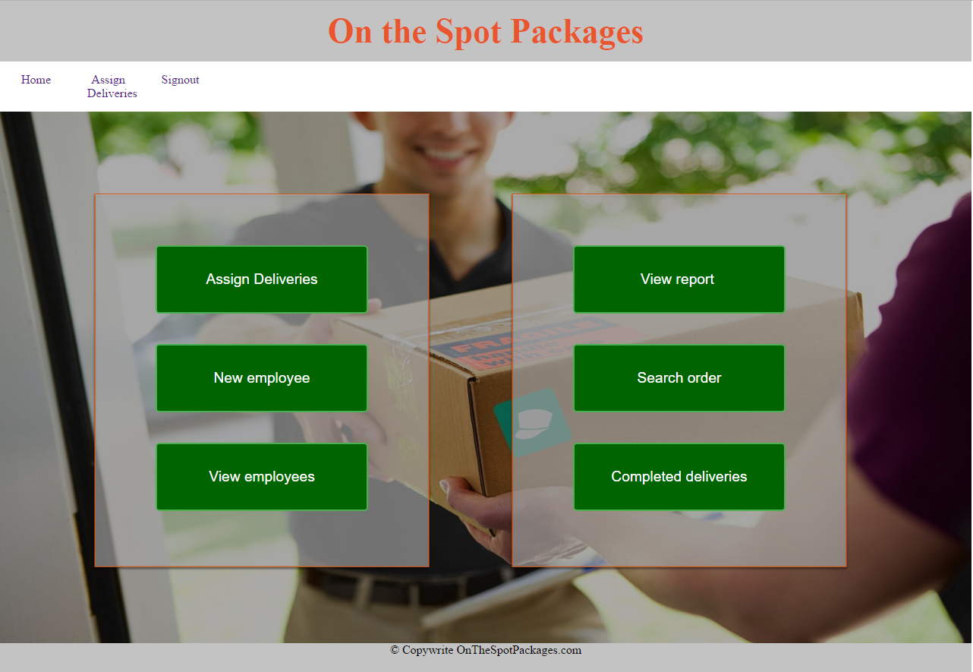

Figure 14: Manager Portal of the website

### 5. View Financial Report:

Financial reports are essential for any business in order to track growth. The report enables the manager to have a quick overview of the business and plan for future improvements. The report is generated with cumulative data retrieved from the database. As the business grows data mining can be helpful in predicting future growth or identifying key issues with the business model. I developed the business report as a part of user story **AACXIV-30: Financial Statement.**

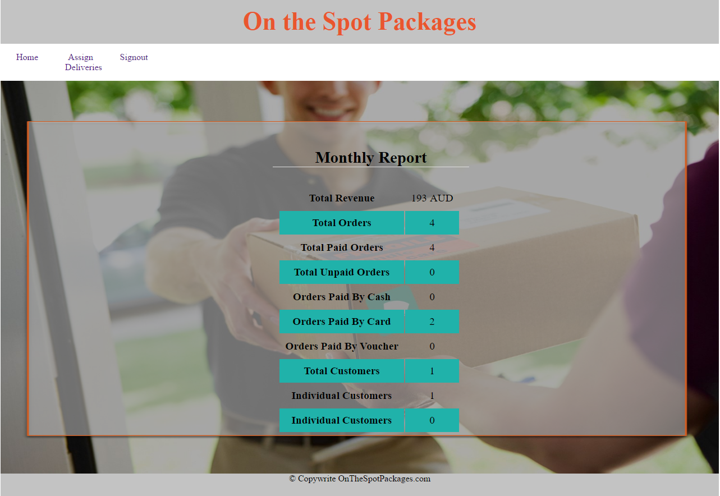

Figure 15: Financial Report

At this stage the report is presented in tabular form showing cumulative data. Addition data fields and graphs can be added for better visualization of the financial status in future releases.

### 6. Database Update:

As new data fields were added to the database table in order to store additional information the database ERD needed to be updated in order to reflect those changes. Orders table was updated to store employee information. Client password information needed to be included in the customers table. The new database tables were manually tested in order ensure all the data were stored properly.

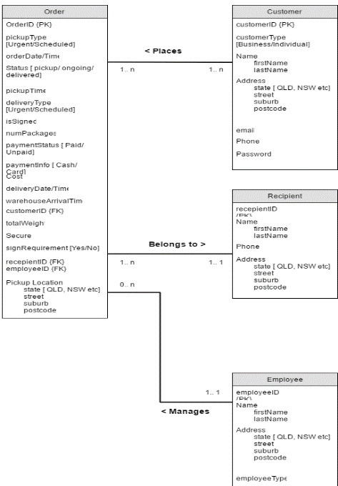

Figure 16: Updated Database ERD

## Sprint 4

### 7. Add new employee through Manager Portal:

Managers can add new employees of the business through the manager portal. Employee details are validated on the server side before storing in the database. A unique employee ID is generated for each new employee. Manager can also view employee details through the portal or assign deliveries to an employee. Adding an employee provides a basic functionality to the portal as employee details are stored securely in the database and makes it easier for the manager to keep track of all the employees.

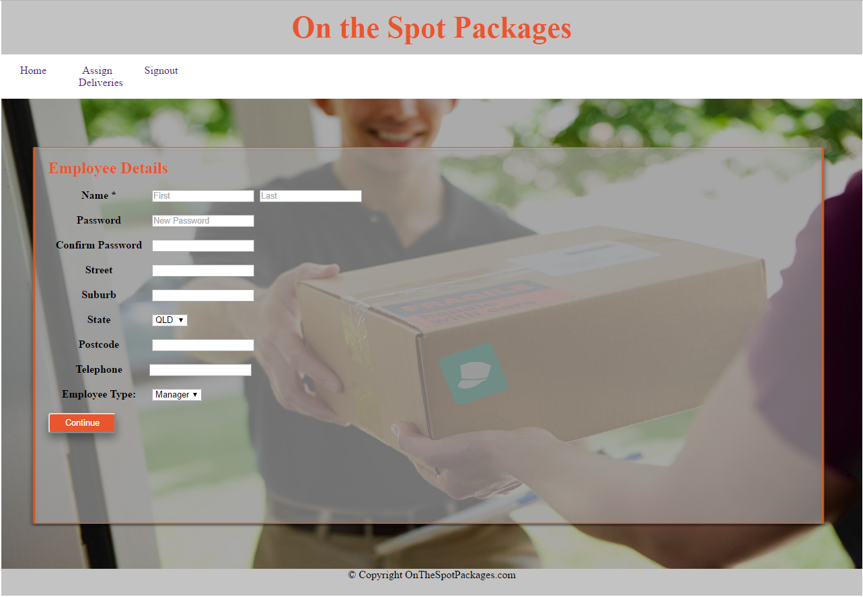

Figure 7: Add new employee through manager portal

In the final design of release 2, employee details cannot be updated through the manager portal. This can be a potential future development for later releases.

### 8. Business Letter:

During the demonstration after sprint 3 the client team was presented with functionalities developed in the last sprint alongside an explanation of the relevance of the completed work to the pre-established user stories. The client team formally provided a feedback to the developer team regarding the demonstration.

I presented the technical aspect of the client team feedback through a business letter. The technical demonstration of the product provided us with further insight of the application. Although the desktop based application looked robust at the time, we would like to see this application being developed for hand held device for increasing efficiency and usability which we discussed during our meeting. The site architecture presented during the demonstration was well planned for functionality and scalability for practical uses. The database tables maintained all the required constraints and the entries were updated as expected. The client feedback is an important aspect of the scrum methodology which helped the teams communicate in an efficient manner.

### 9. Sprint Plans:

I helped in developing detailed task plan for sprint 3 & 4. Each user stories were divided into sub – tasks for developing different aspects of the functionality. The tasks were equally shared by the members of the scrum team keeping a healthy balance. Taking in consideration the current team velocity each sprint consisted of roughly 13 story points. The time assigned for each user story was proportional to the story points. Some tasks took less effort and time compared to the previous sprints as the developers were well accustomed to the system environment by this point.

AACXIV-18: Email Confirmation System user story was postponed to a later release as the task has a low priority in the initial user stories and release plan, after careful consideration and discussion with the client team and developer team, we decided to push the task to a later sprint. This task will be considered as a future development once the entire site is completed.

At the end of release 2 a sprint back log was developed consisting of further development work in the future. Future improvement to the website was suggested in release 3 user stories. Sprint 5 was planned for Release 3 based on the suggested user stories.

### 10. Update Customer Details:

I added additional functionality in the customer portal which enables the customer to update personal details. The changed details are stored in the database once validated. The changes are reflected in the portal instantly. This provides the customer with more flexibility in managing their profile.

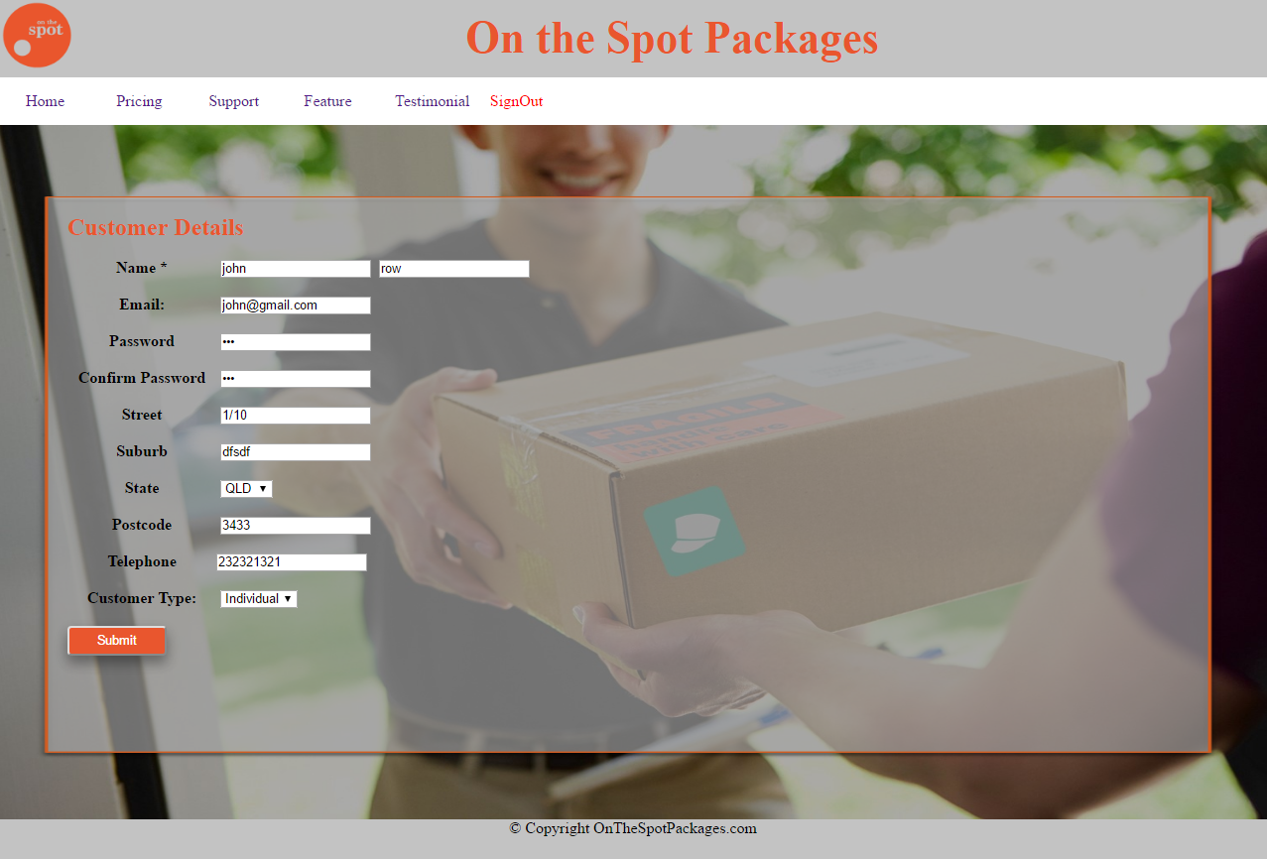

Figure 8: Customer Details Update

### 11. Track Order:

I implemented the functionality to track any order through the customer portal. This provides reliability and security of the package. This is an important part of customer service which completes the user story **AACXIV-31: Order Tracking**.

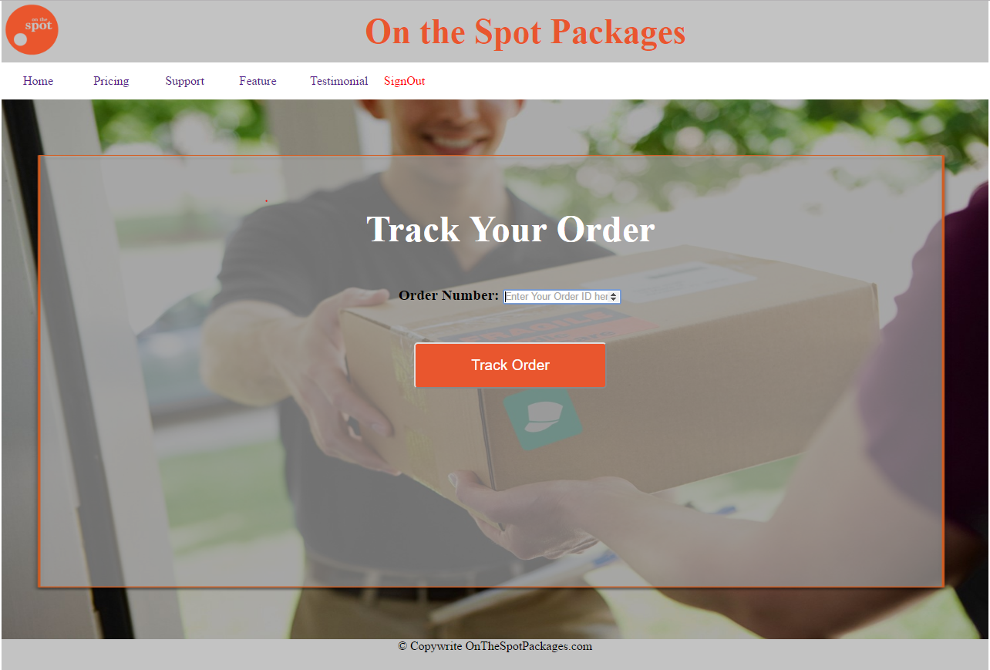

Figure 9: Order Tracking Page